|  |
| --- |
| SAKURA CO. |
| Alien Explorer |
| **GAME2014 Assignment 2 (Part 2)** |
| Version #1.1  All work Copyright © 2021 by Sakura Games.  All rights reserved. |
| **Sojung (Serena) Lee - 101245044** |
|  |

|  |
| --- |
| December 12th, 2021 |

Contents

Version History 3

Game Overview 5

Controls 5

Interface Sketch 6

Level 1 9

Level 2 10

Level 3 11

Menu and Screen Descriptions 12

Game World 16

Levels 17

Characters 17

Enemies 18

Weapons 18

Scoring 18

Sound Index 19

Art / Multimedia Index 20

# **Version History**

Version 1.0

* Added Game Overview
  + Described entire description of how the game works and the goal of the game
* Added Controls
  + Described the game control UI for touch screen
  + Described how the game control relates to player’s movement
* Added all Interface sketches of mobile game layout
  + Screenshots added: Entire layout of game, Main Menu, Instructions, Credits, Level 1, Level 2, Level 3, Game Over
* Added Screen Descriptions
  + Described the design and the goal for each screen
  + Added screenshots of each game screen from Unity Editor
  + Screens added: Main Menu, Instructions, Credits, Level 1, Level 2, Level 3, Game Over
* Added Game World
  + Described the different types of platforms and themes the game world will have
* Added Levels
  + Described the three levels the game world will have
  + Described the goal for each level
  + Described the types of enemies and platform each level has
* Added Character
  + Described the player and its abilities
* Added Weapons
  + Described the player’s weapon
* Added Scoring
  + Described the basic scoring system for game
  + Items (e.g. gold stars) & coins will boost scoring system
  + Enemies and obstacles the player has dodged will increase score
* Added Sound Index
  + Added types of sound effects and background music each screen will have
* Added Art / Multimedia Index
  + Added types of art assets used for the game
  + Added screenshots and descriptions for each character, enemy, platform, and items that will be used in the game

Version 1.1

* Updated Game Overview
  + Updated number of platforms displayed in game world
  + Updated player’s weapon choice
  + Updated number of lives player has (from 3 to 10)
* Updated Character
  + Updated number of lives/health counter from 3 to 10
  + Added attacking capabilities
* Updated weapon
  + Player can use up to 10 bullets to attack enemies
  + Added specific details to bullet behavior and weapon conditions
* Updated Interface Sketches
  + Added Game Won and Game Over screens
* Updated Menu and Screen Descriptions
  + Added Game Won and Game Over screens
  + Updated all screens with new camera/screen resolution (e.g. 800x600 to 3040x1440)
  + Updated Level 3 and Level 2 screen descriptions to reflect new enemies and platforms
* Updated Game World
  + Updated number of platform types (e.g. previously 3 new types, but now 6 new types)
* Updated Levels
  + Updated number of new platforms and enemies introduced in each level
* Updated Scoring System
  + Updated number of points enemies and items will have
* Updated Sound Index
  + Added new shooting sound effect
  + Added new explosion sound effect
  + Added new UI button click sound effect
* Updated Art / Multimedia Index
  + Updated flags for exiting and entering level
  + Updated enemies
  + Updated obstacles placed & added death plane
  + Added star item
  + Added new types of platforms – bouncy, slippery, exploding

# **Game Overview**

The goal of the game is to reach the end of the level by killing enemies and collecting items for as many points as possible.

The player will be transported to a level map, which is decorated with platforms of different colors. The player’s goal is to complete the level map by running on top of platforms. The player must dodge or kill the enemies to get past them. The player also must collect items to increase their game score.

There will be 6 different types of platforms in the game. These platforms will be more thoroughly explained in the Game World section of the Game Design Document.

Once the player starts playing the game, they will be transported to the first level. Once they completed the first level of the game, they will move on to the second level, and so forth. If the player dies within 10 lives in any of the levels, the player will be transported back to the Game Over screen. The user will have the option to restart the game from Level 1 or to the Menu screen. The player stats will be updated back to its original stats. For example, the player’s lives will go back to 10, the number of bullets will go back to 10, and the score will go back to zero.

The player can die from losing all 10 health hearts. The player can lose 1 heart health icon by touching an enemy or falling off their platform and touching the death plane/floor down below.

# Controls

The game controls include the mobile device touch screen. The user can click buttons on the mobile device touch screen to move the player. The mobile device touch screen will display the control joysticks and/or buttons. For example, the mobile device touch screen will display one joystick for player movement, another button for the player to jump, and other button for the player to shoot. There will be one joystick button for the player to move the game avatar. It will be placed on the left side of the screen. The two other buttons, shooting button and the jumping button, will be placed on the right side of the screen.

# Interface Sketch

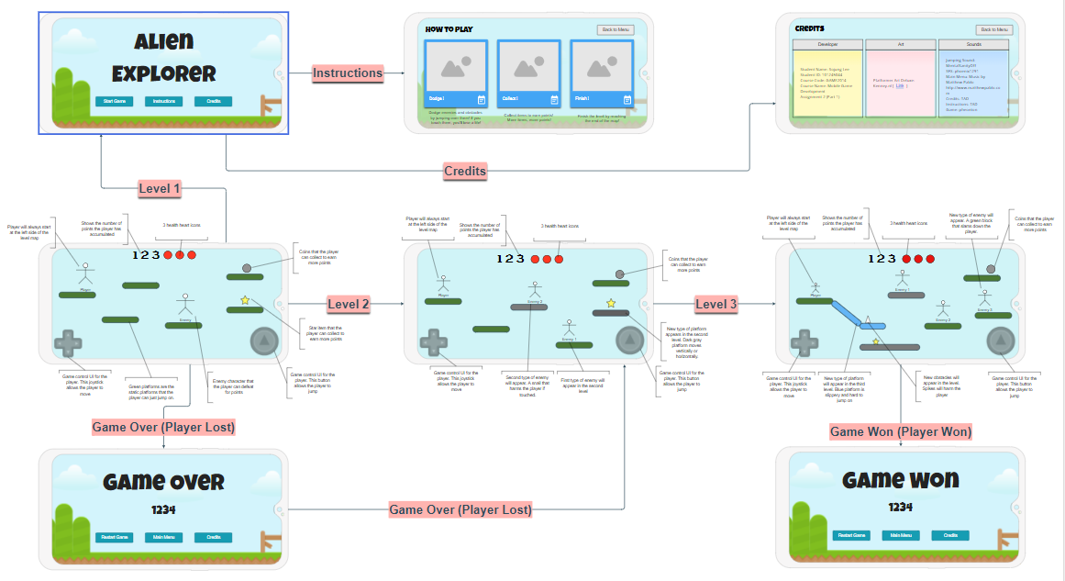

## Level 1

## Level 2

## Level 3

# Menu and Screen Descriptions

## 

This is the main menu screen. It demonstrates 3 different buttons: “Start”, “How to Play”, and “Credits”. The start button takes the player to the main game screen. The “How to Play” button takes the player to the instructions screen. The “Credits” button takes the player to the credits screen.

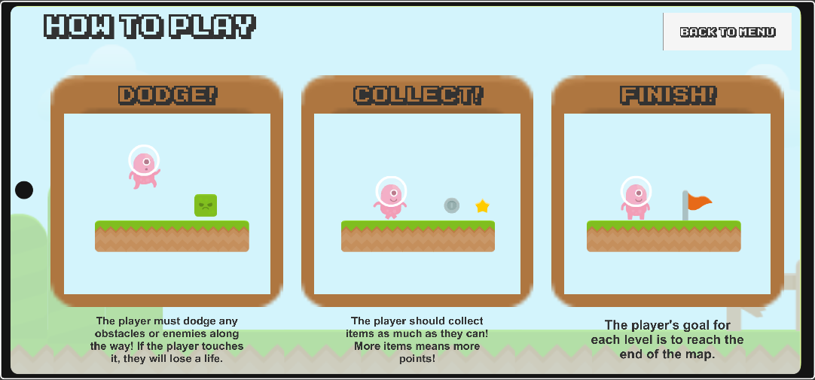

This is the instructions screen that tells the player how to play the game. The three main goals for the game are to dodge the enemies and the obstacles, collect items and coins for more points, and to finish the game level map. Under each image there is a description just in case the player needs more help to understand the goals of the game.

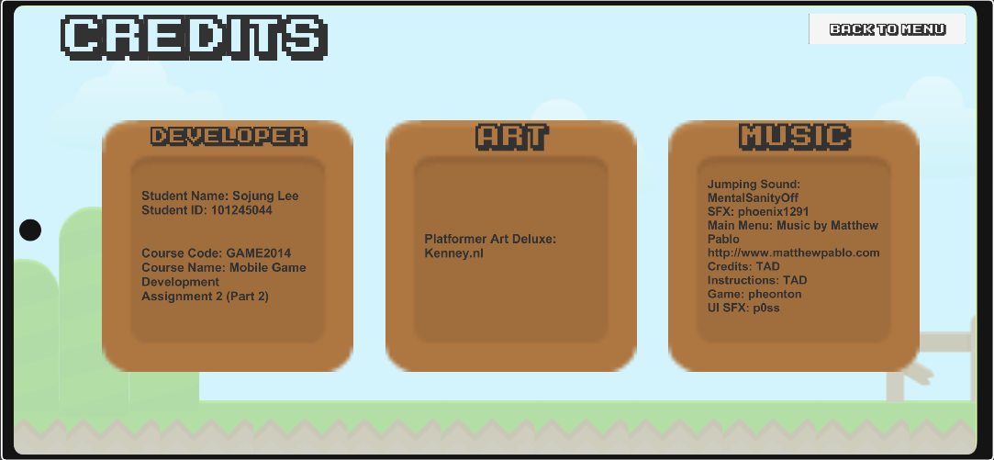

This is the credits page of the game. It shows the developer credits (game developer and programmer), also giving information about the creator of the game. It also shows the creator for the art (artist) and the name of the art asset package. The last box shows the credits for the music used for the game. Different sound effect musicians and game background music musicians were credited to their own liking.

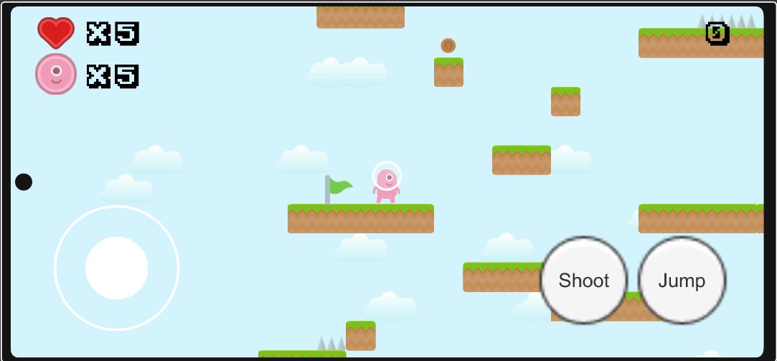

This is the first level of the game. It shows the player the game UI controls on the screen, shows the green flag (where the player first starts in the game), the type of platform used in the first level, what items would be available to the player, and what type of enemy will be placed. So far, the player will only be exposed to one type of enemy and platform to make sure the player understands the basic mechanics of the game. The health, ammo, and score text will be displayed.

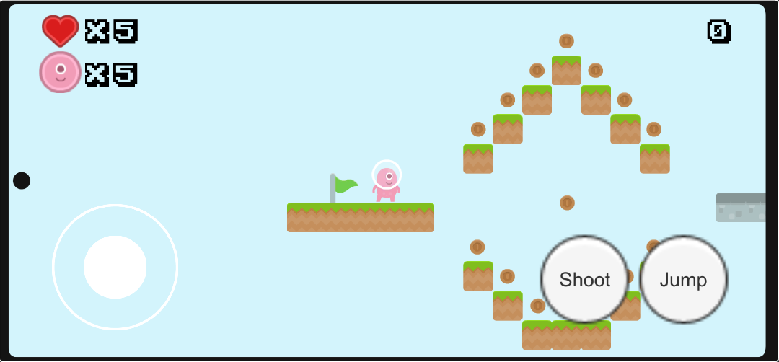

This is the second level of the game. This shows new types of platforms used in the game, as well as the new type of enemy. The types of items will be the same in the level. The dark gray platform will be the new type of platform that will be exposed to the player. It will move vertically or horizontally. The player will need to have good timing to jump onto the platforms to successfully pass this level. The health, ammo, and score text will be displayed.

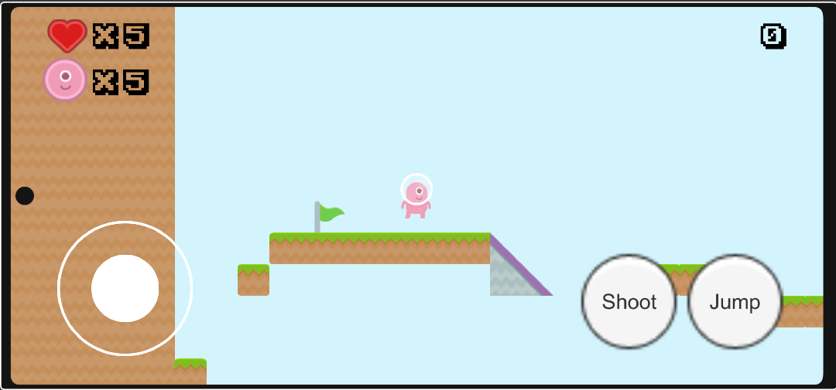

This is the third level of the game. It will introduce a new type of platform. The purple platform will have a slippery material so the player might have difficulty jumping and landing onto the new platform. This level will introduce new types of obstacles such as the spike. The health, ammo, and score text will be displayed.

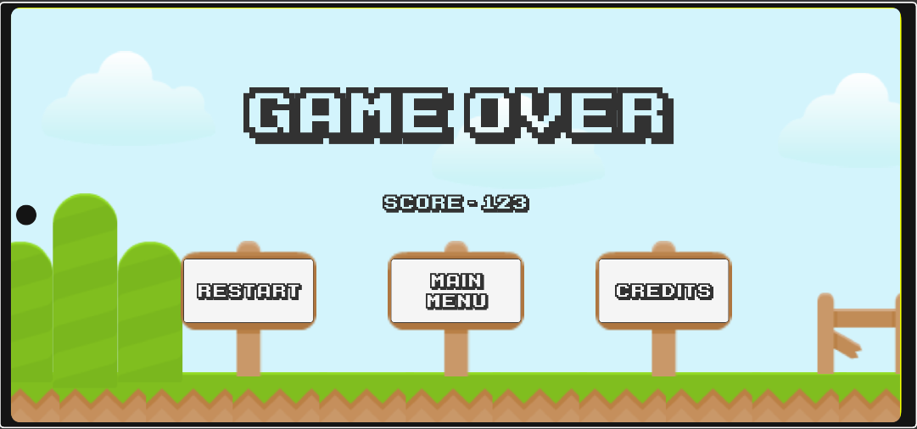

This it the game over screen. This screen will appear whenever the player runs out of the lives. It will show the player the accumulative number of points the player gained throughout the entire game they will alive. The game over screen will then show 3 buttons: “Restart”, “Main Menu”, and “Credits”. The “Restart” button will take the player back to the first level so that they can restart the game with zero points and full health. The “Main Menu” button allows the player to go back to the main menu screen. The “Credits” button allows the player to see the credits. If they were to go back to the credits screen, the player will go back to the main menu from there.

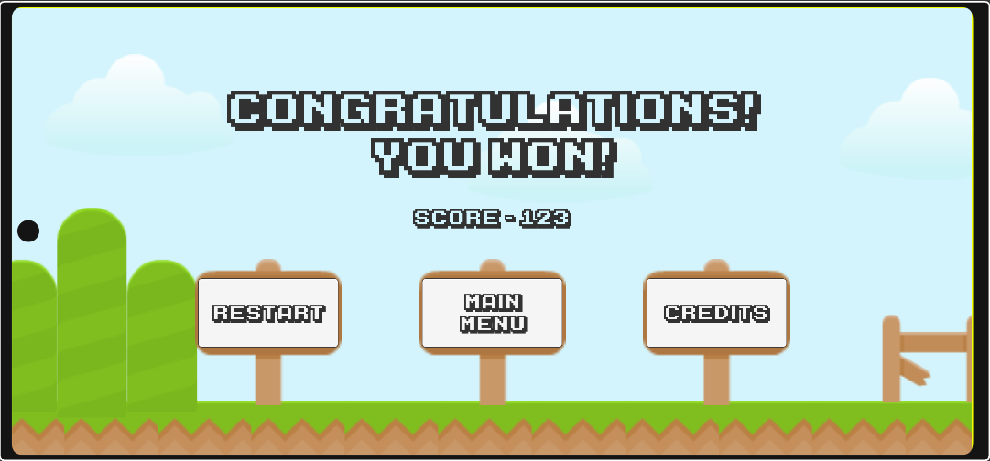

This it the game won screen. The screen will appear once the player reaches the final finished (red) flag in the last level, Level 3. The game win screen will display a congratulation message and the player’s final score. Also, it will have 3 buttons for the player to interact: restart the game back to level 1, return to the main menu, or show the credits.

# Game World

The game world will differently types of platforms decorated throughout each level. The platforms and the game world will have pastel, light-colored themed platforms, and background.

There will be 6 different types of platforms – each will have their own unique color to represent the different types.

The first type of platform is the normal floating static platform. This basic platform will have no movement and will have no special characteristics. It will be the first platform the player will be introduced to. It will have no special materials. It will have green grass on top and brown color for the platform land. [Link] for the image.

The second type of platform is the floating horizontal movement platform. This platform will move horizontally only. The player must use timing techniques to take advantage of this platform. This platform will have a bouncy special material. The speed of the platform moving horizontally will vary between each platform and/or level. In the early stages of the gameplay, this type of horizontal platform will move slowly. However, as the game progresses, the speed of this platform will move faster to add challenges for the player. It will have a gray stone texture. [Link] for the image.

The third type of platform is the floating vertical movement platform. This platform will move vertically only. This platform will act like the horizontal-moving platform. The player must use timing techniques to take advantage of this platform. This platform will have no special materials. The speed of the platform will vary between levels and each platform has the possibility to be different as well. As the game progresses, the speed of this platform will increase. It will have a gray stone texture. [Link] for the image.

The fourth type of platform will be the slippery platform. It will be a slope with a special material. The special material will have little to no friction. This will allow the player to slide down the platform. The player will have to carefully tread upon this platform as there could be a possibility that an enemy or an obstacle will be placed at the end. It will have an icy texture and theme to the platform to indicate the platform will be slippery. This platform does not float. [Link] for the image.

The fifth type of platform will have a bouncy platform. It will have horizontal or vertical movement. This platform will have a special material that adds bounciness to the player and there will be very little friction. This platform floats. [Link] for the image.

The sixth, and the last, type of platform is the exploding platform. This platform is the very similar to the bouncy platform except that it ‘explodes’ or deletes itself after the player touches it once. An exploding sound effect will play. This platform also has a ‘bomb’ icon to indicate that it is an ‘exploding’ platform. The platform will then bounce the player back off, thus acting as a physical repercussion to the player. [Link] for the image.

# Levels

There will be 3 levels in total for this gameplay.

The first level will introduce the player to the new game world. It will have the first type of platform (static movement). It will also have basic enemies to dodge and simple obstacles that the player will have avoid. This will introduce basic gameplay mechanics to the player. Obtainable objects, such as coins and stars, will be introduced as well. The goal of this level is to introduce the player to the new game world, get used to the game play mechanics, and understand how to complete the level.

The second level will introduce the player to new platform types. This level will have 2 more types of platforms, along with the first type of platform. The type of platforms will include normal platforms, horizontal and vertical platforms, and exploding platforms. The goal of this level will be to introduce the players new types of platforms, enemies, and obstacles. The level will increase in difficulty with the new platforms and enemies. The new enemy, the fast snail, will also be introduced.

The third level will introduce the platform to two more new platform types. The new types of platforms are slippery platforms and the bouncy platforms. This level will have all types of platforms and will be significantly longer than the first two levels. This level also has randomized items appearing in the level.

# Characters

The player avatar will be a pink alien that will match the theme of the game. It will have jumping capabilities to jump on top of the platforms. There will be no special material attached to the player. The player will be able to kill the enemies with bullets. The player will only have 10 bullets in its arsenal. The player cannot regain those bullets, however. The number of bullets will reset every level. The player will not have any special movement abilities through the game. This will add difficulty to the game play.

# Enemies

There will be 2 types of enemies: slime and fast snail.

The first type of enemy would be a simple slime. The slime is a traditional enemy that moves slowly so it allows the player to test out the jumping functionality and the dodging game play mechanic. It should move horizontally across the platform. If the player touches the slime, then it will hurt the player and the player will lose 1 heart health icon. The slime will use line of sight to patrol its own platform and not fall off its platform. The slime will not move if it detects the player.

The second type of enemy is a fast snail. The snail will move horizontally across any platform (except the slippery platform). This snail has a line of detection towards the player. The snail will move towards the player extremely fast if the player is nearby. This will cause the player to time the dodging well. The snail can move fast enough so if the player misjudges the dodge or the jump, the snail can attack the player. However, if the player is not nearby, the snail will use line of sight to try to patrol its own platform.

# Weapons

The player will 10 bullets to use. If the player runs out, they will not be able to regain those bullets back. The bullets will disappear if they touch an enemy or go out of their pre-determined distance range. The player will be able to press the “Shoot” button on the mobile UI control or the “E” button on their keyboard to shoot a bullet. The bullet will only be able to move horizontally. The number of bullets will reset after the player goes onto the next level or restarts the game.

# Scoring

The scoring will be based off the items the player collected and how many obstacles and enemies the player dodged.

|  |  |
| --- | --- |
| Items | Points |
| Stars | 100 Points |
| Gold Coins | 50 Points |
| Silver Coins | 25 Points |
| Bronze Coins | 5 Points |

For every enemy and obstacle, the player dodged, it will range between 10 points to 50 points.

|  |  |
| --- | --- |
| Enemies Killed | Points |
| Slime | 20 |
| Snail | 50 |

# Sound Index

|  |  |  |
| --- | --- | --- |
| Character | Action | Link |
| Player | Player jumping | <https://opengameart.org/content/jump-landing-sound> |
| Player | Player obtaining coin | <https://opengameart.org/content/sound-effects-pack-2> (Coin 2) |
| Player | Player obtaining star | <https://opengameart.org/content/sound-effects-pack-2> (Coin 4) |
| Player & Enemy | Player colliding with Slime or Snail | <https://opengameart.org/content/sound-effects-pack-2> (Hit 2) |
| Player | Player Shoots | <https://opengameart.org/content/sound-effects-pack-2> (Hit 5) |
| Player | Player dies | <https://opengameart.org/content/sound-effects-pack-2> (Lose 9) |
| Player | Player wins | <https://opengameart.org/content/sound-effects-pack-2> (1up 1) |
| Player | Platform explodes | <https://opengameart.org/content/interface-sounds-starter-pack> (drop) |
| Player | Player clicks on buttons | <https://opengameart.org/content/interface-sounds-starter-pack> (appear-online) |

|  |  |
| --- | --- |
| Screen | Link |
| Main Menu Screen | <https://opengameart.org/content/pleasant-creek> |
| Credits Screen | <https://opengameart.org/content/lofi-compilation> (Bartender) |
| Instructions Screen | <https://opengameart.org/content/8-bit-lofi-ice-cave> |
| Game Play Screen  Game Over Screen  Game Won Screen | <https://opengameart.org/content/one> |

# Art / Multimedia Index

|  |  |
| --- | --- |
| Description  (Player, Enemy, Item, Obstacle, Platform) | Image |
| Player |  |
| Enemy – Slime |  |
| Enemy – Snail |  |
| Item – Bronze Coin |  |
| Item – Silver Coin |  |
| Item – Gold Coin |  |
| Item – Star |  |
| Obstacle – Spikes / Death Plane |  |
| Platform – Static (Non-Moving) |  |
| Platform – Horizontally Moving |  |
| Platform – Vertically Moving |  |
| Platform – Slippery |  |
| Platform – Exploding |  |
| Platform - Bouncy | S |
| Décor – Exit Sign |  |
| Décor – Start Sign |  |